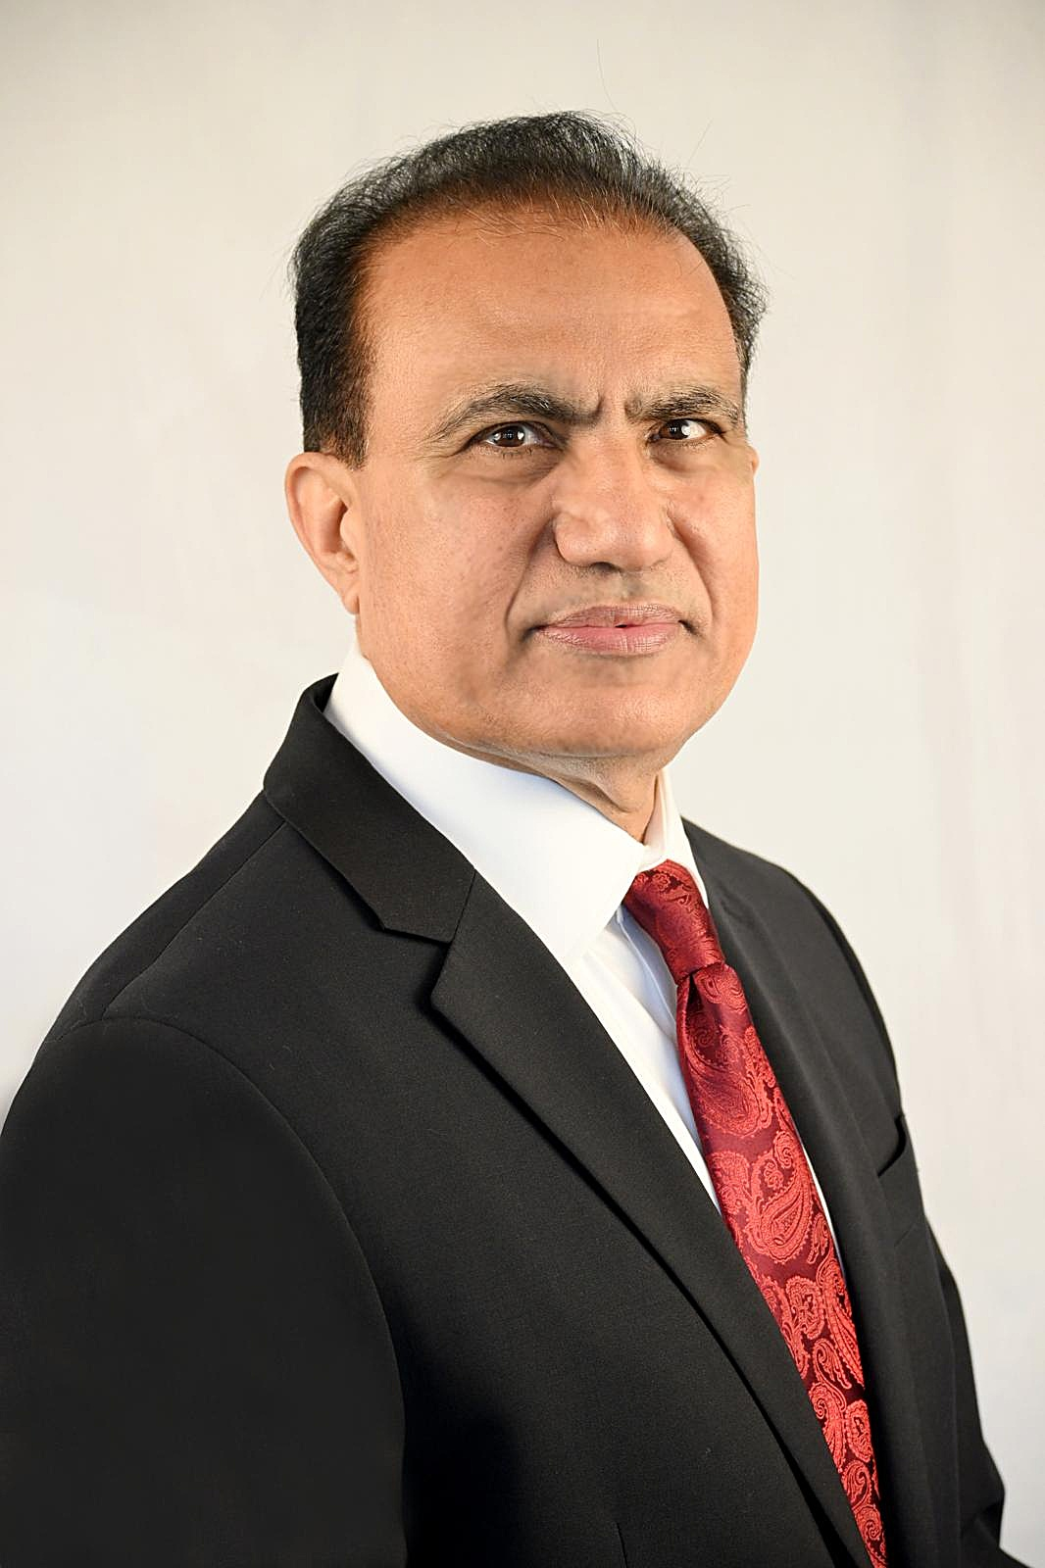 | Ehtsham Haq, MD  Community Volunteer | Healthcare Executive | Clinical Professor  Distinguished Fellow, American Psychiatric Association  Dedicated. Experienced. Independent. Trustworthy. Conflict Resolver.

APPNA SERVICE
The Intent and eagerness to serve the APPNA community as a volunteer has been always at the forefront of my mind for last 20 years. It has been an honor holding chair and advisory roles spanning national healthcare initiatives, CME programming, international meetings, and strategic planning. My breadth of engagement reflects a sustained, multi-level commitment to advancing the association's mission.

LEADERSHIP AREAS
Healthcare Administration | Psychiatry Education | APPNA Service
Telehealth Leadership | Community Free Clinic Care | CME Program Leadership
Residency Training | Governance & Committees | Physician Advocacy

- 2025-26 Advisor, APPNA National Health Care Day
- 2025 Member, AIMCAANA Ethics & Grievance Committee
- 2025 Chair, APPNA International Meeting Iceland & Norway
- 2023/26 Chair, PAPANA CABL Committee
- 2022 Chair, APPNA Strategy Meeting
- 2023 Member, APPNA CABL Committee
- 2021 Co-Chair APPNA CME Program at Summer Convention (Thursday CME)
- 2019/2017 Chair, APPNA CME International Meetings (Norther Pakistan Trip and Alaska Cruise)
- 2018/2015 Chair, APPNA National Health Care Day (chair/advisor several years)
- 2018 Member, APPNA Advocacy Committee
- 2013 Chair, AIMCAANA CABL Committee
- 2010 AIMCAANA Council-at-Large (for several years)
- 2008 Member, AIMCAANA Finance Committee
- 2007-2008 Member, APPNA Council as Alabama Chapter President
- 2007 Chair, CABL Committee Alabama Chapter
COMMUNITY SERVICE
Driven by a deep sense of social responsibility, I founded the Red Crescent Clinic of Alabama along with other community members— a free clinic providing medical care to underserved communities. I have served simultaneously as its Board Chair, Medical Director, and treating clinician, embodying hands-on leadership at every level. Beyond the clinic, I have organized fundraising and advocacy events throughout Alabama to amplify access to care and advance health equity in the region and Pakistani Americans.
- 2002 President & Secretary Muslim Community of Birmingham Alabama (MCBA)
- 2012 Founding Member, Red Crescent Clinic of Alabama (RCCA) Free Clinic
- 2012 Chair, Medical Director, and Clinician, RCCA Free Clinic
- 2024 Hosted and organized fundraising events in Alabama
- 2025/2015 Chair & Advisor, APPNA National Health Care Day
- 2026 Organized community advocacy events in Alabama
LEADERSHIP
My leadership career spans executive clinical roles at the BVA Healthcare System — including Chief of Mental Health and Director of Telehealth Services — as well as governance positions on medical staff, peer review, and disciplinary boards. As founder of the APPNA Alabama Chapter and former Chief Resident at UAB, Chief MH Services, Clinical Professor at UAB, I have shaped physician communities at many levels. My commitment to continuous professional development is reflected in an extensive portfolio of leadership training programs completed through VHA, Disney Institute world Executive’s Leadership Training, and other executive forums.

- 2001-2002 Chief Resident, University of Alabama at Birmingham Department of Psychiatry
- 2005-2018 Chief, Birmingham VA (BVA) Mental Health Healthcare System
- 2018-2024 Director of Telehealth Services, BVA Healthcare System
- 2005-2018 Chair, VA Mental Health Executive Committee
- 2005-2018 Member, Served on VISN 7 Mental Health Directors Committee
- 2005-2018 Member, Served on Medical Staff Executive Committee
- 2005-2018 Served on Professional Standards Board, Physician Pay Panel, and Peer Review Committees
- 2007 Founder, APPNA Alabama Chapter
- 2010 Completed VHA 2010 Leadership Conference: Be the Change You Want to See
- 2011 Completed Disney Institute World Executives Leadership Training
- 2014 Completed VISN 7 Leadership Training
- 2014-2024 Chair, Secretary, and Member, VHA Disciplinary Appeals Board
- 2015 Completed VACO Mental Health Leadership Training
- 2015 Completed The 7 Habits of Highly Effective People Leadership Training
- 2016 Completed Crucial Conversations Workshop Leadership Training
- 2017 Completed VHA Leaders Developing Leaders Program
- 2018 Completed Clinical Executive Leadership Training Program
ACADEMIC APPOINTMENTS & CONTRIBUTIONS
As a Clinical Professor at the UAB School of Medicine and a Distinguished Fellow of the American Psychiatric Association, I have made enduring contributions to medical education and psychiatric training. I established and directed the VA-site Psychiatry Residency Program and has served key UAB committees medical school admissions, residency training, and educational programming. Mentorship of international medical graduates — including Pakistani residency applicants — reflects my dedication to broadening pathways into American medicine for the next generation of physicians.
- 2002-2018 Member, UAB Psychiatry Residency Training Committee
- 2002-Present Supervised externships for Pakistani residency applicants and local graduates
- 2005 Initiated VA-site Psychiatry Residency Program
- 2005-2018 Director, VA Medical Center Psychiatry Residency Program
- 2010-2018 Member, UAB School of Medicine Admissions Committee
- 2017-2024 Clinical Professor, University of Alabama at Birmingham (UAB) School of Medicine
- 2020 Distinguished Fellow, American Psychiatric Association
- 2023 Member, APA Caucus on Social Determinants of Mental Health

PROFESSIONAL IMPACT
Career contributions reflect sustained commitment to physician leadership, academic training, community-based care, and organizational service at the local, alumni, and national levels.

